COLLEGE MANAGEMENT SYSTEM

Develop by: Prachi Navik, Dhruvi Patel

INDEX

|  |  |  |
| --- | --- | --- |
| SrNo. | Topic | No. |
| 1 | Introduction |  |
| 2 | Objective |  |
| 3 | Tools and Technologies |  |
| 4 | UML(usecase) |  |
| 5 | Modules and Functionalities |  |
| 6 | Database |  |
| 7 | Screenshots |  |
| 8 | Future Enhancement |  |

INTRODUCTION:

The title of the project is “COLLEGE MANAGEMENT SYSTEM”

The system is an Intranet based application that aims at providing information to all the levels of management within an organization and other student. This system can be used as a information management system for the college and other student. For a given student/staff (Technical / Non-technical) the Administrator creates login id & password, using these student/ staff (Technical / Non-technical) can access the system to either upload or download some information from the database

This project is aimed at developing College Management System that is of importance to either an educational institution or a college. The system is an Intranet based application that can be accessed throughout the institution or a specified department. This system is being developed for a college to maintain and facilitate easy access to information. For this the users need to be registered with the system after which they can access or modify data as per the permissions given to them.

**OBJECTIVES**

This is a web-oriented application *allows* us to *access* the whole *information about the college, staffs, students, facilities etc.* This application provides a virtual tour of Campus. Here we will get the latest information about the students and staffs. This generic application designed for assisting the students at an institute regarding information on the courses, subjects, classes, assignments, grades and timetable. It also provides support that a faculty can also check about his daily schedule, can upload assignments, and notices to the students. Here administrator will manage the accounts of the student and faculties, makes the timetable, and upload the latest information about the campus.

**TOOL AND TECHNOLOGIES**

* HTML
* CSS
* BOOTSTRAP
* JAVASCRIPT
* PHP
* JSON
* jquery

**USER-WISE FUNCTIONALITIES**

* ADMIN
* Database management
* User profile management
* Course detail management
* Permissions
* Website update
* Login
* Logout
* Student
* Student profile
* View projects
* Faculty list
* Add project
* Login
* Logout
* Faculty
* Faculty profile
* Student details
* Projects
* Login
* Logout
* Guest
* College tour
* Admission portal

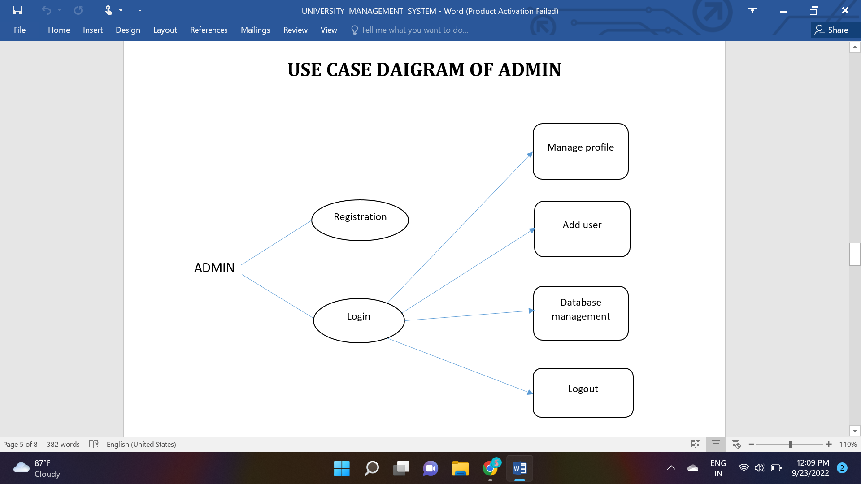

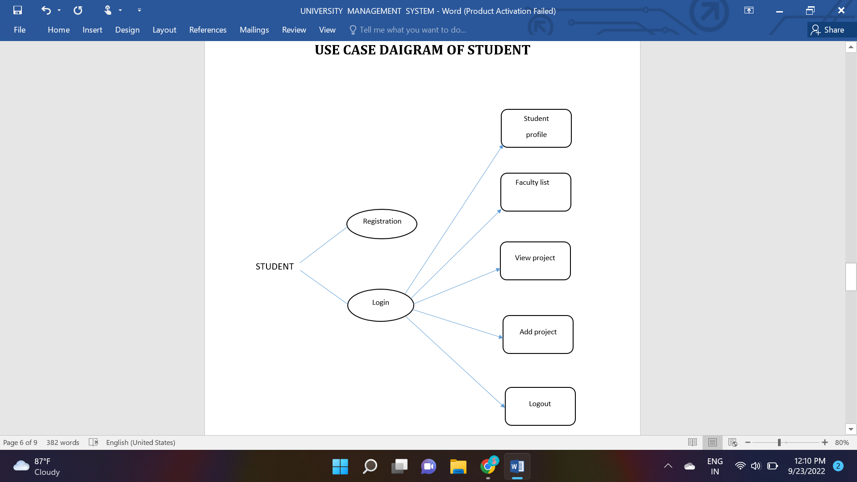

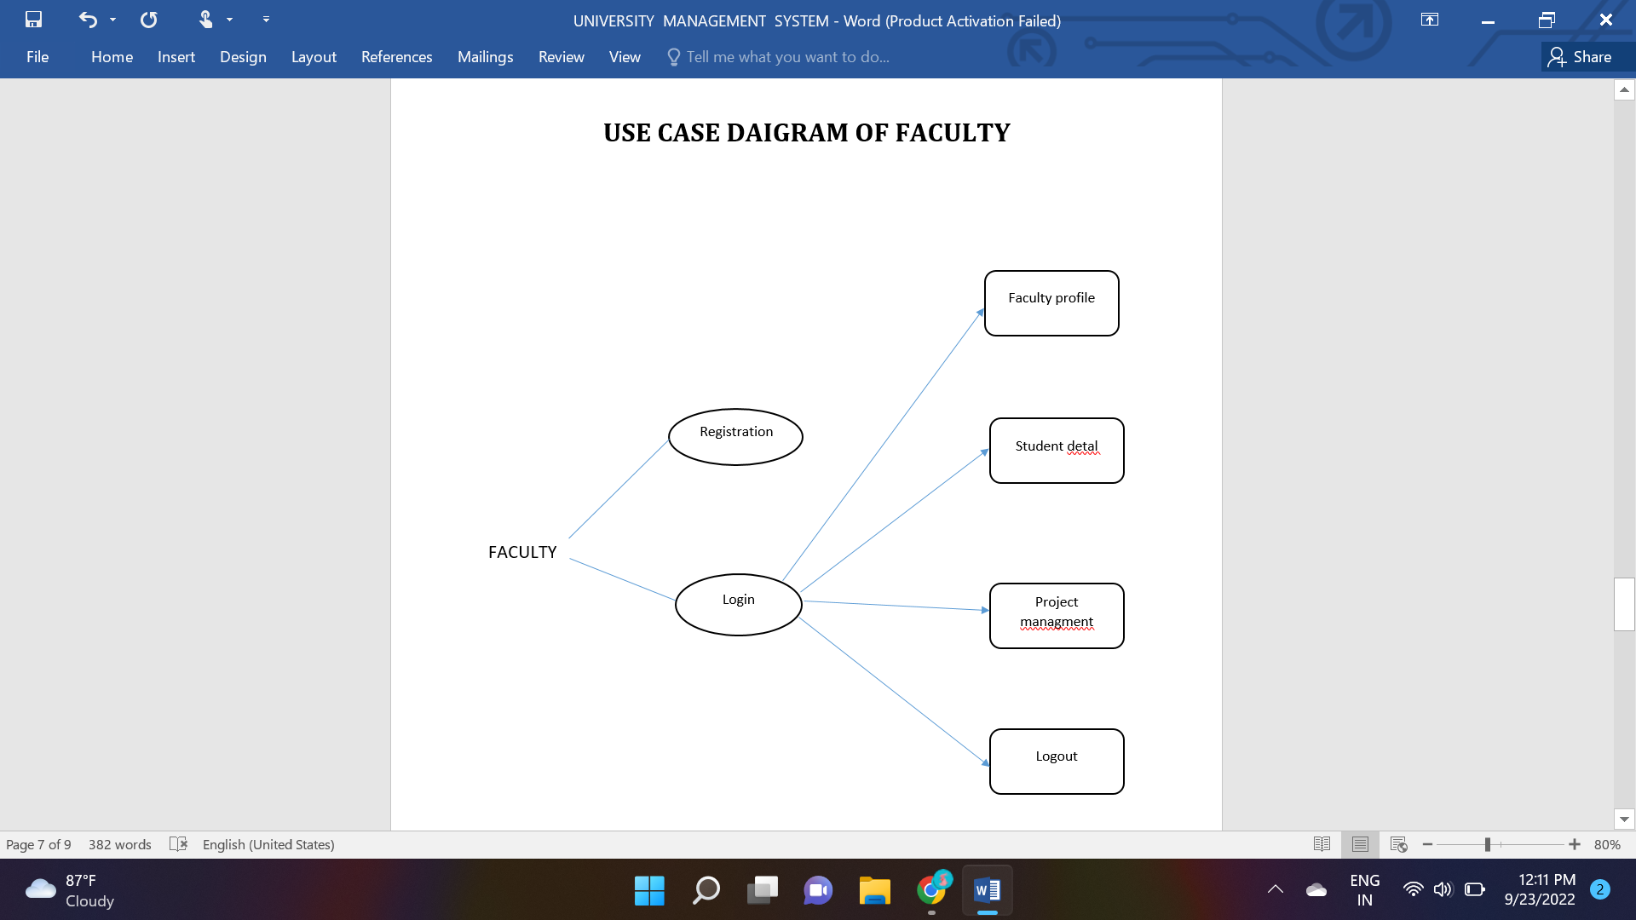

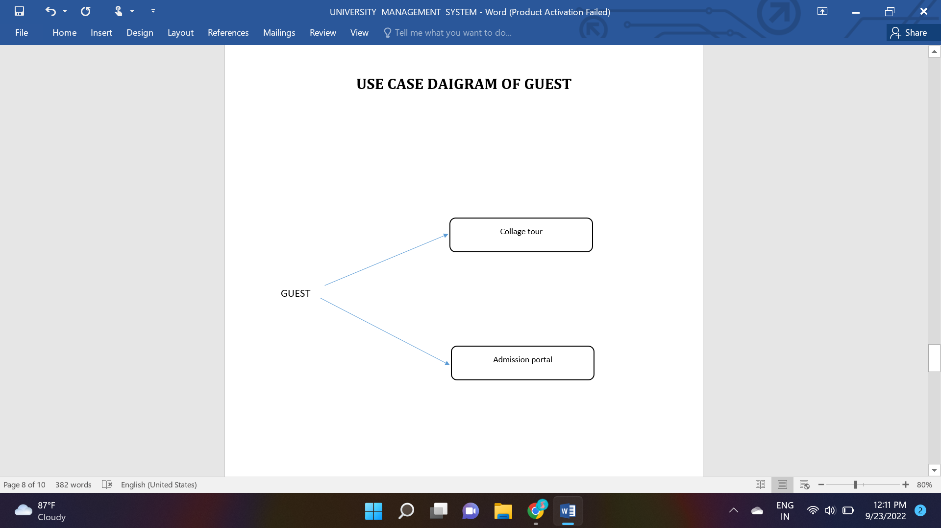

**DATABASE**

**Projuser:**

|  |  |  |  |
| --- | --- | --- | --- |
| # | Name | Type | Null |
| 1 | user_id | Int(10) |  |
| 2 | user_name | Varchar(50) |  |
| 3 | password | Varchar(8) |  |
| 4 | User_roll_number | Int(10) |  |
| 5 | phone_number | Int(10) |  |
| 6 | email | Varchar(30) |  |
| 7 | user_year | Int(4) |  |
| 8 | last_login | tmestamp |  |
| 9 | user_address | Varchar(100) |  |
| 10 | user_department | Varchar(50) |  |
| 11 | user_type | Varchar(50) |  |

**DATABASE**

**Project:**

|  |  |  |  |
| --- | --- | --- | --- |
| # | Name | Type | Null |
| 1 | user_id | Int(20) |  |
| 2 | user_id | Int(30) |  |
| 3 | Project_title | Varchar(50) |  |
| 4 | Projrct_type | Varchsr(50) |  |
| 5 | Project_allocation | date |  |
| 6 | Project_status | Varchar(50) |  |
| 7 | Project_statusdate | date |  |
| 8 | Project_supervisor | Varchar(50) |  |
| 9 | User_name | Varchar(50) |  |
| 10 | Project_department | Varchar(50) |  |
| 11 | Project_requirements | Varchar(100) |  |
| 12 | Project_objective | Varchar(100) |  |
| 13 | Project_background | Varchar(100) |  |
| 14 | Project_file_path | Varchar(200) |  |
| 15 | view | Varchar(50) |  |
| 16 | allow | Varchar(50) |  |
| 17 | reject | Varchar(50) |  |

**DATABASE**

**ProjectStatusmap:**

|  |  |  |  |
| --- | --- | --- | --- |
| # | Name | Type | Null |
| 1 | id | Int(50) |  |
| 2 | project_status | Varchar(50) |  |
| 3 | project_status_type | Varchar(50) |  |

**Projecttypemap:**

|  |  |  |  |
| --- | --- | --- | --- |
| # | Name | Type | Null |
| 1 | id | Int(50) |  |
| 2 | Project_criteria_name | Varchar(50) |  |
| 3 | Project_type | Varchar(50) |  |

**Registration:**

|  |  |  |  |
| --- | --- | --- | --- |
| # | Name | Type | Null |
| 1 | name | Varchar(50) |  |
| 2 | email | Varchar(50) |  |
| 3 | pin | Int(10) |  |
| 4 | course | Varchar(50) |  |
| 5 | state | Varchar(50) |  |
| 6 | city | Varchar(50) |  |
| 7 | addrese | Varchar(50) |  |
| 8 | contsct | Int(10) |  |

**SCREENSHOTS**



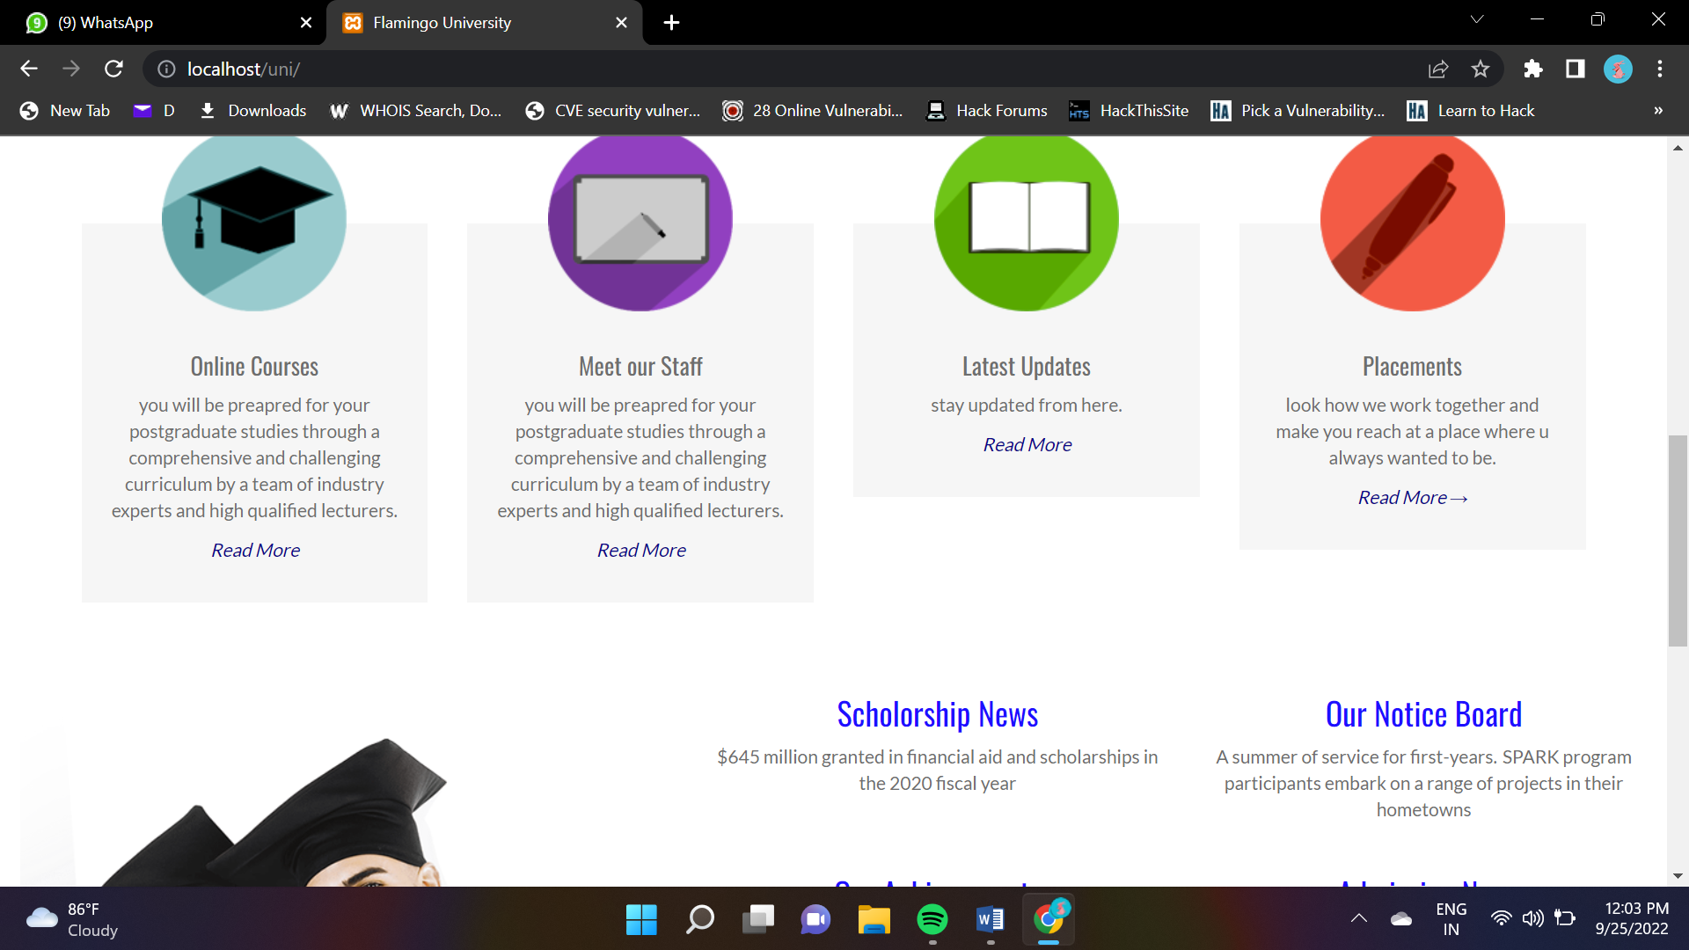



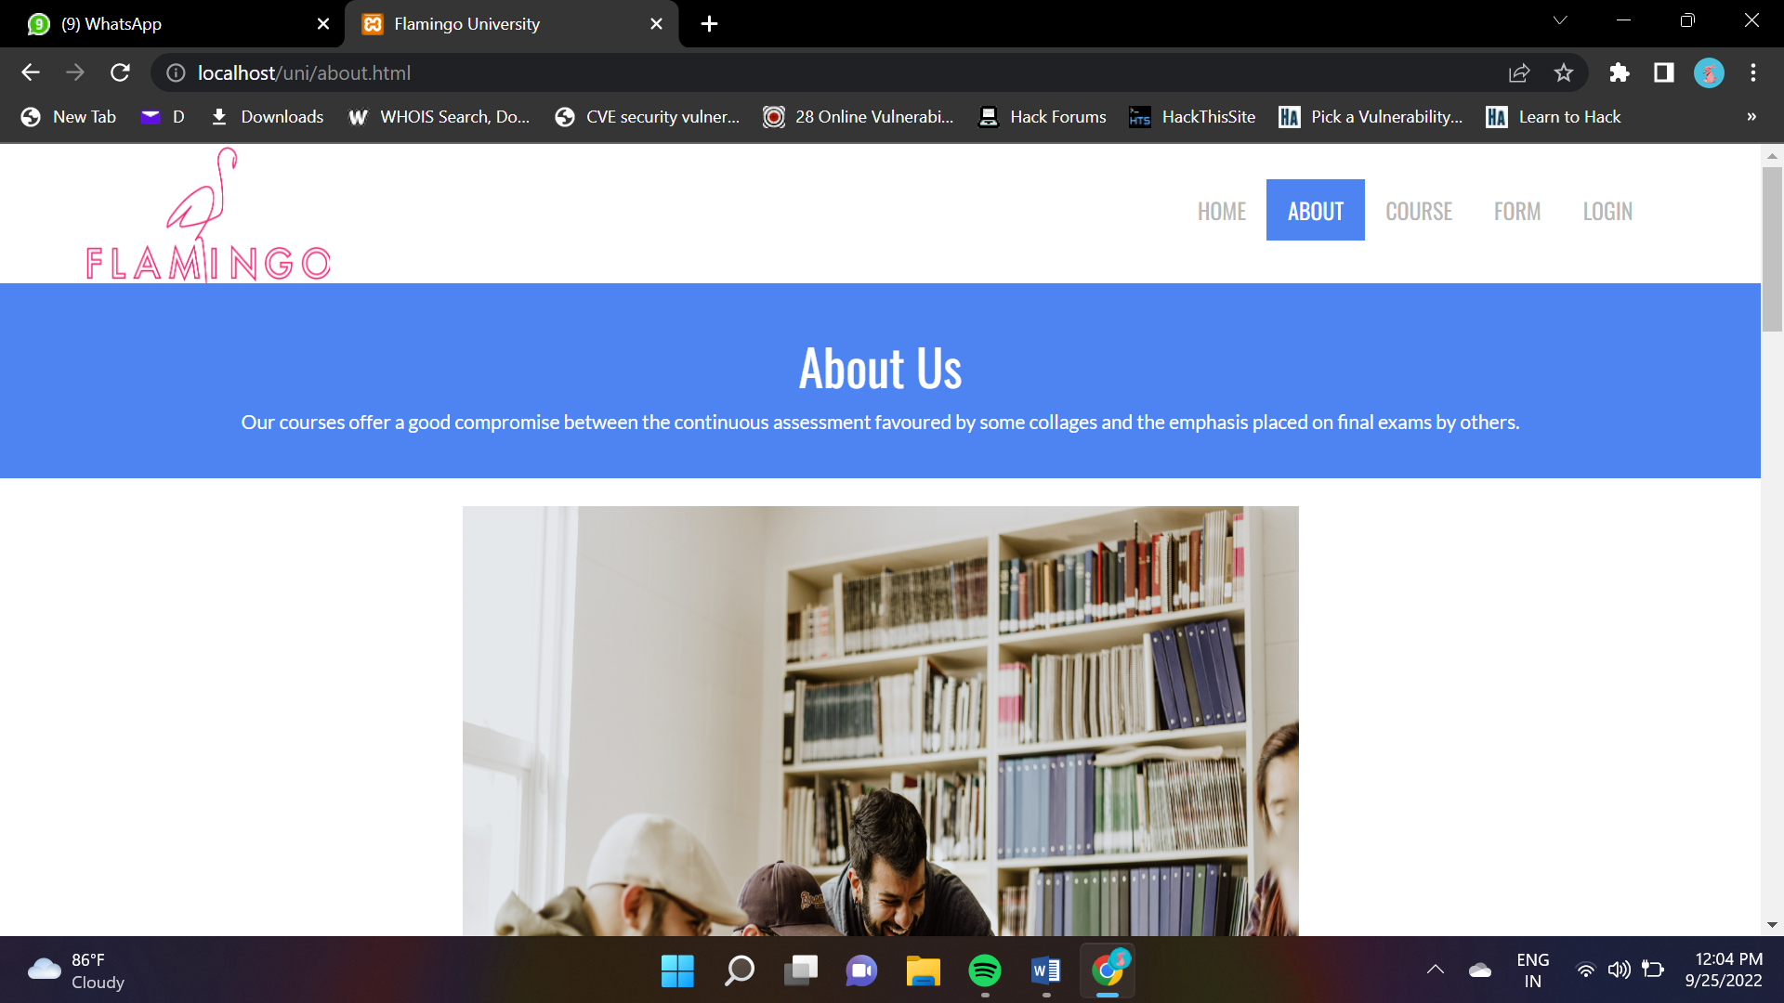



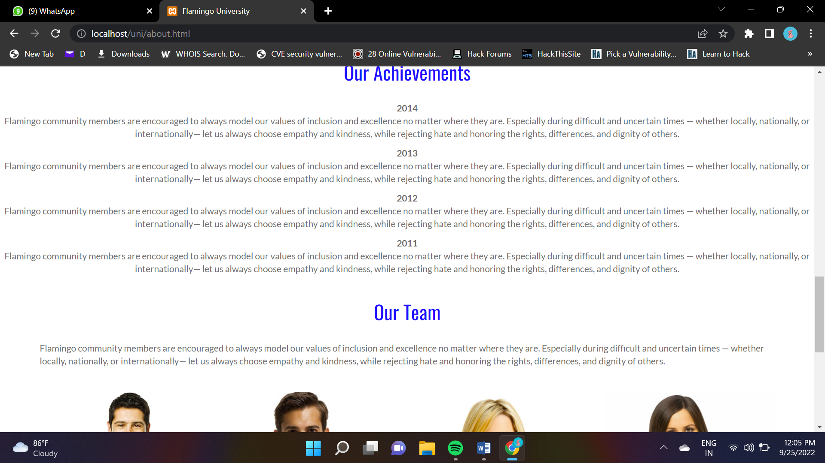

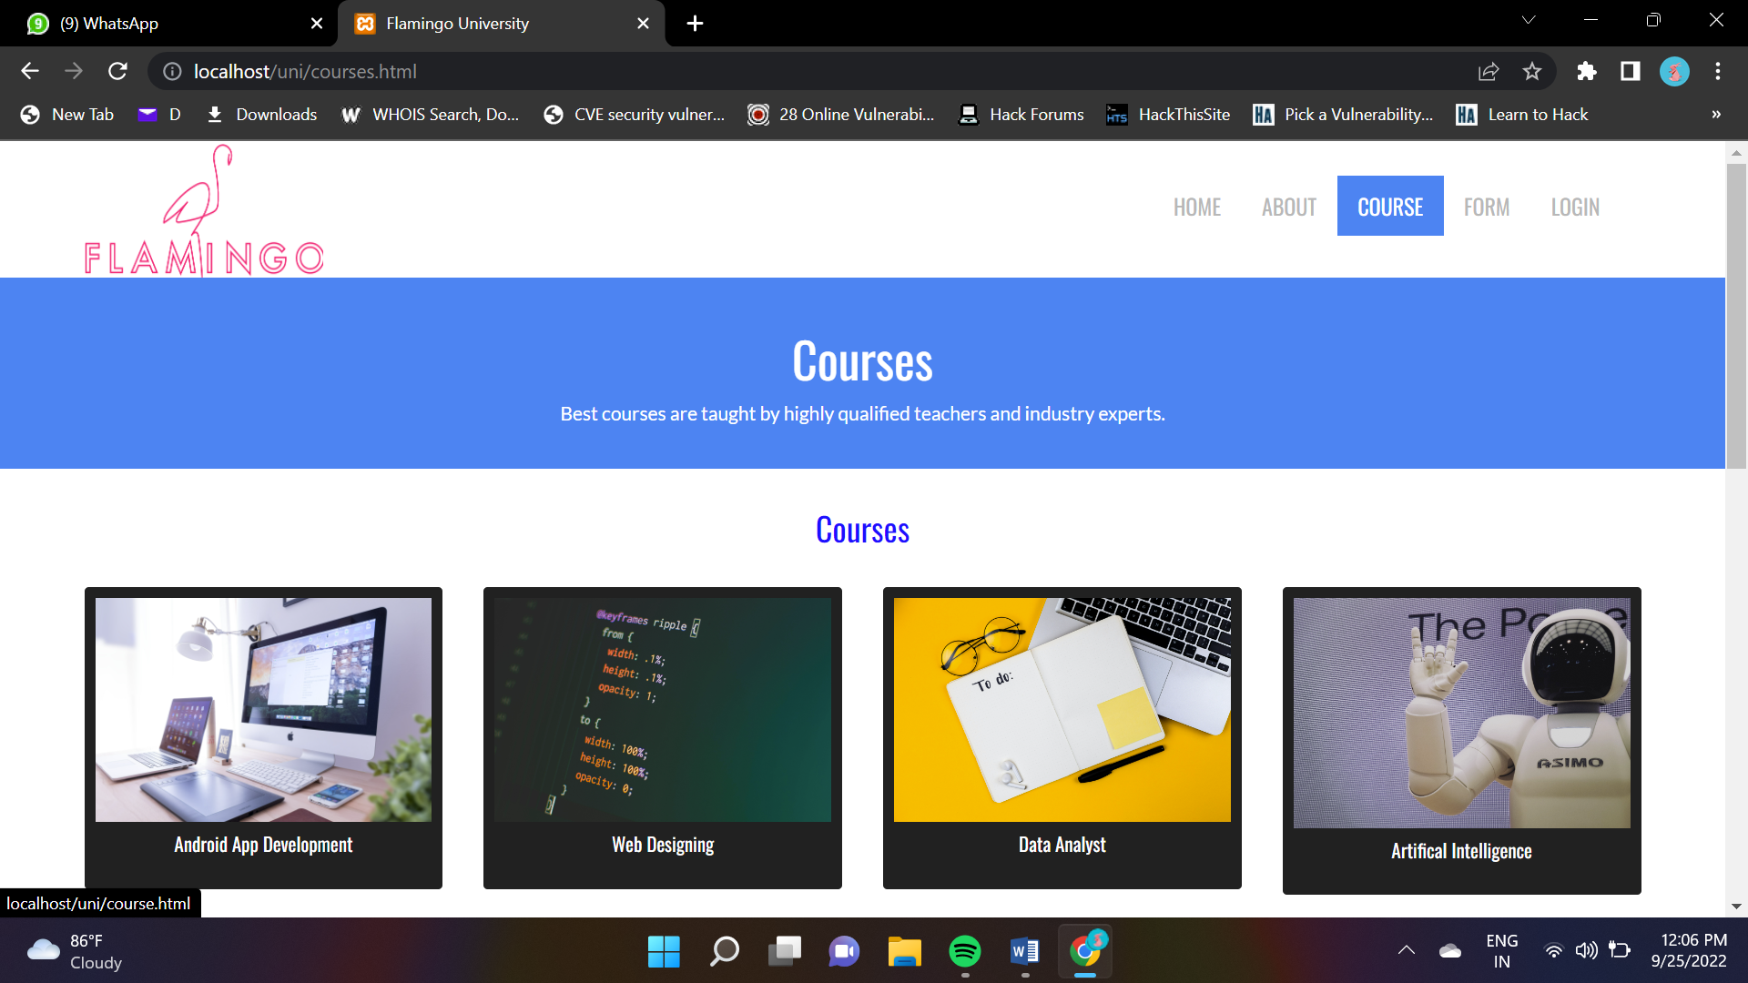

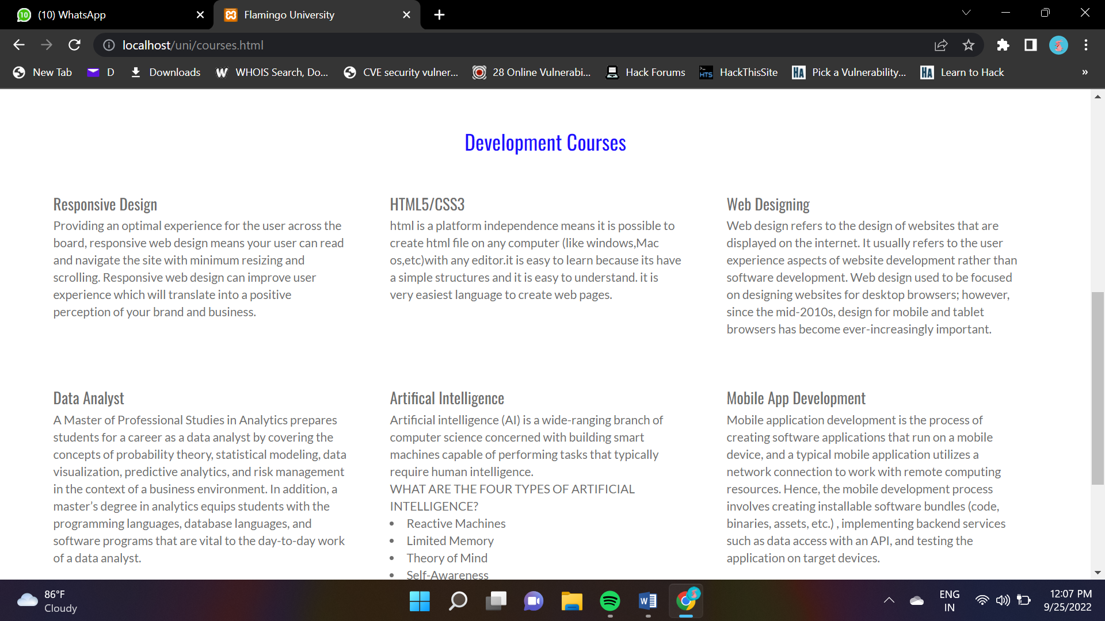

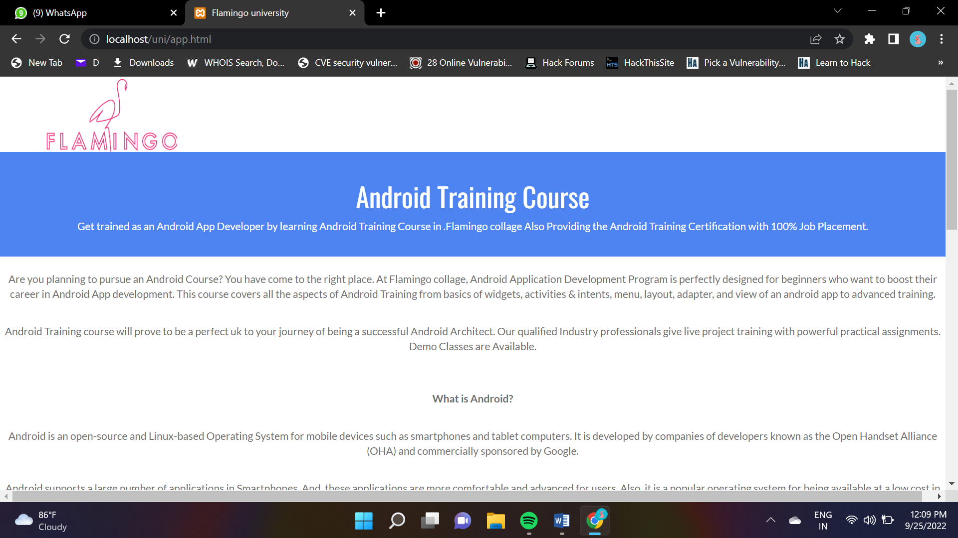

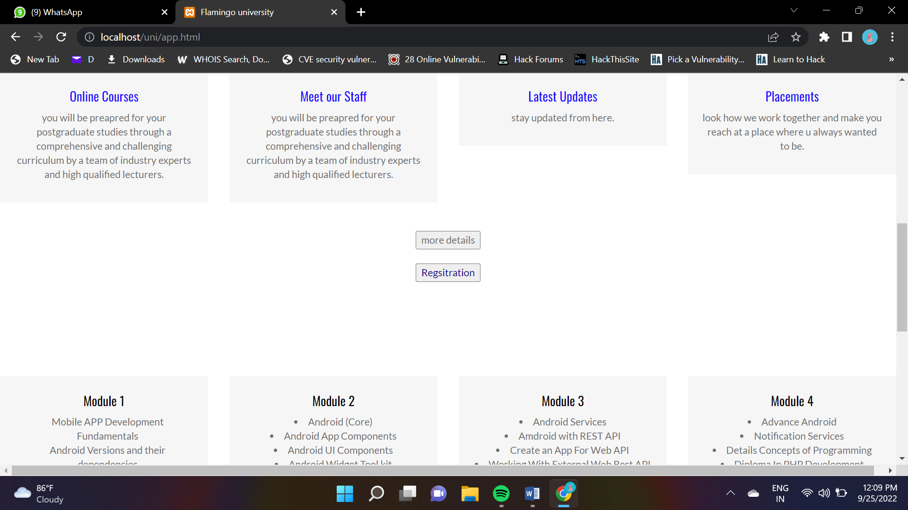

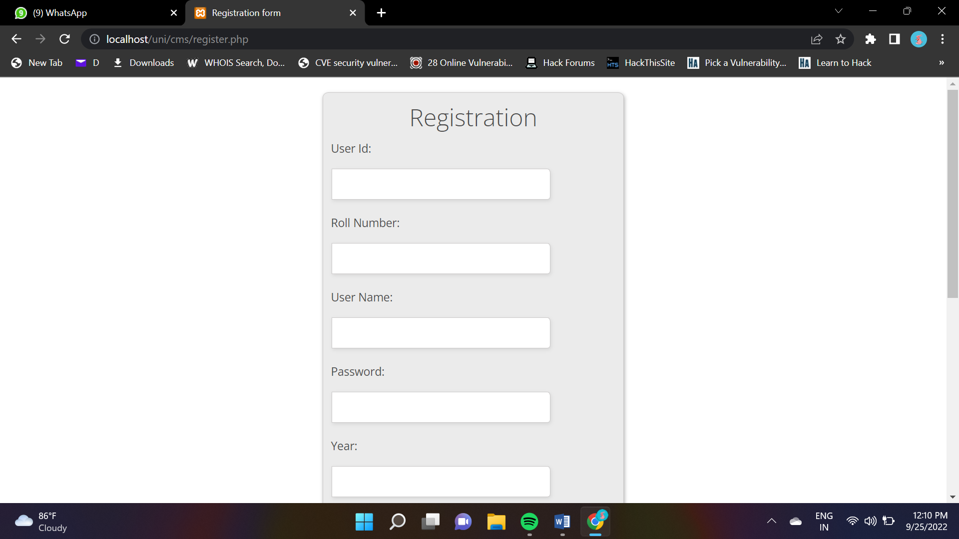

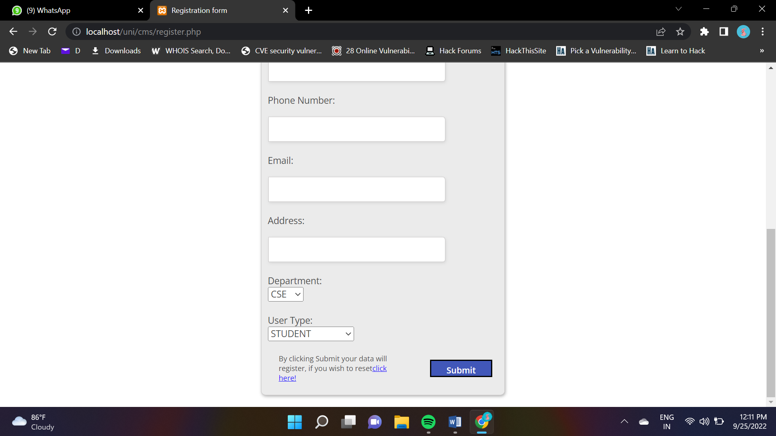

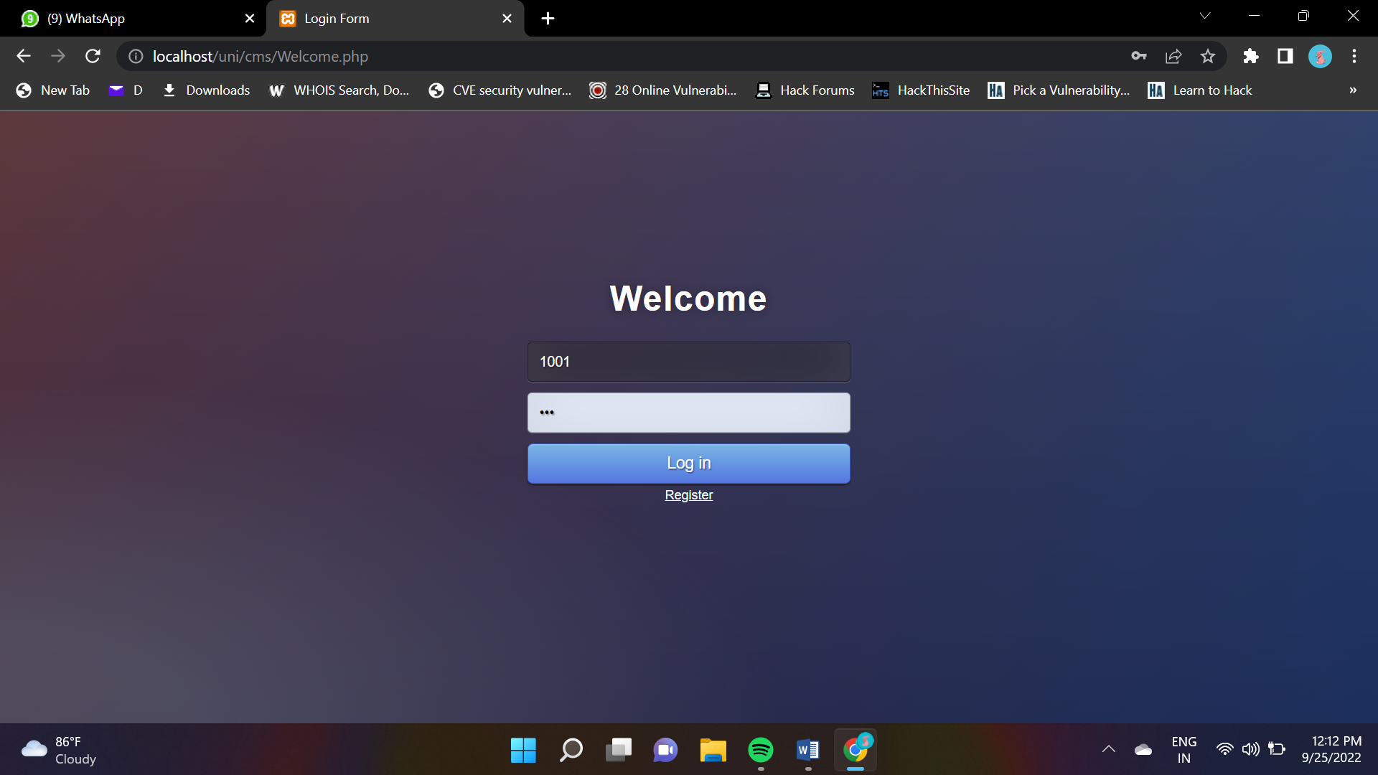

Admin side:

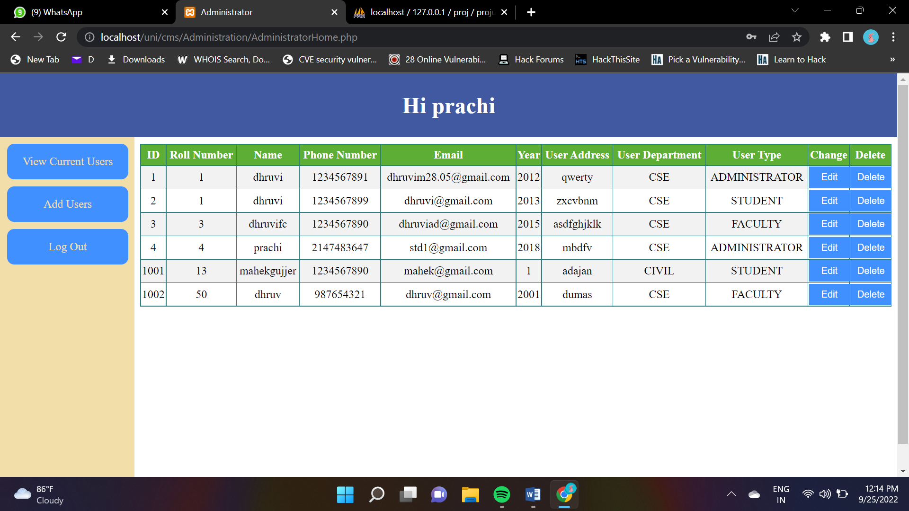

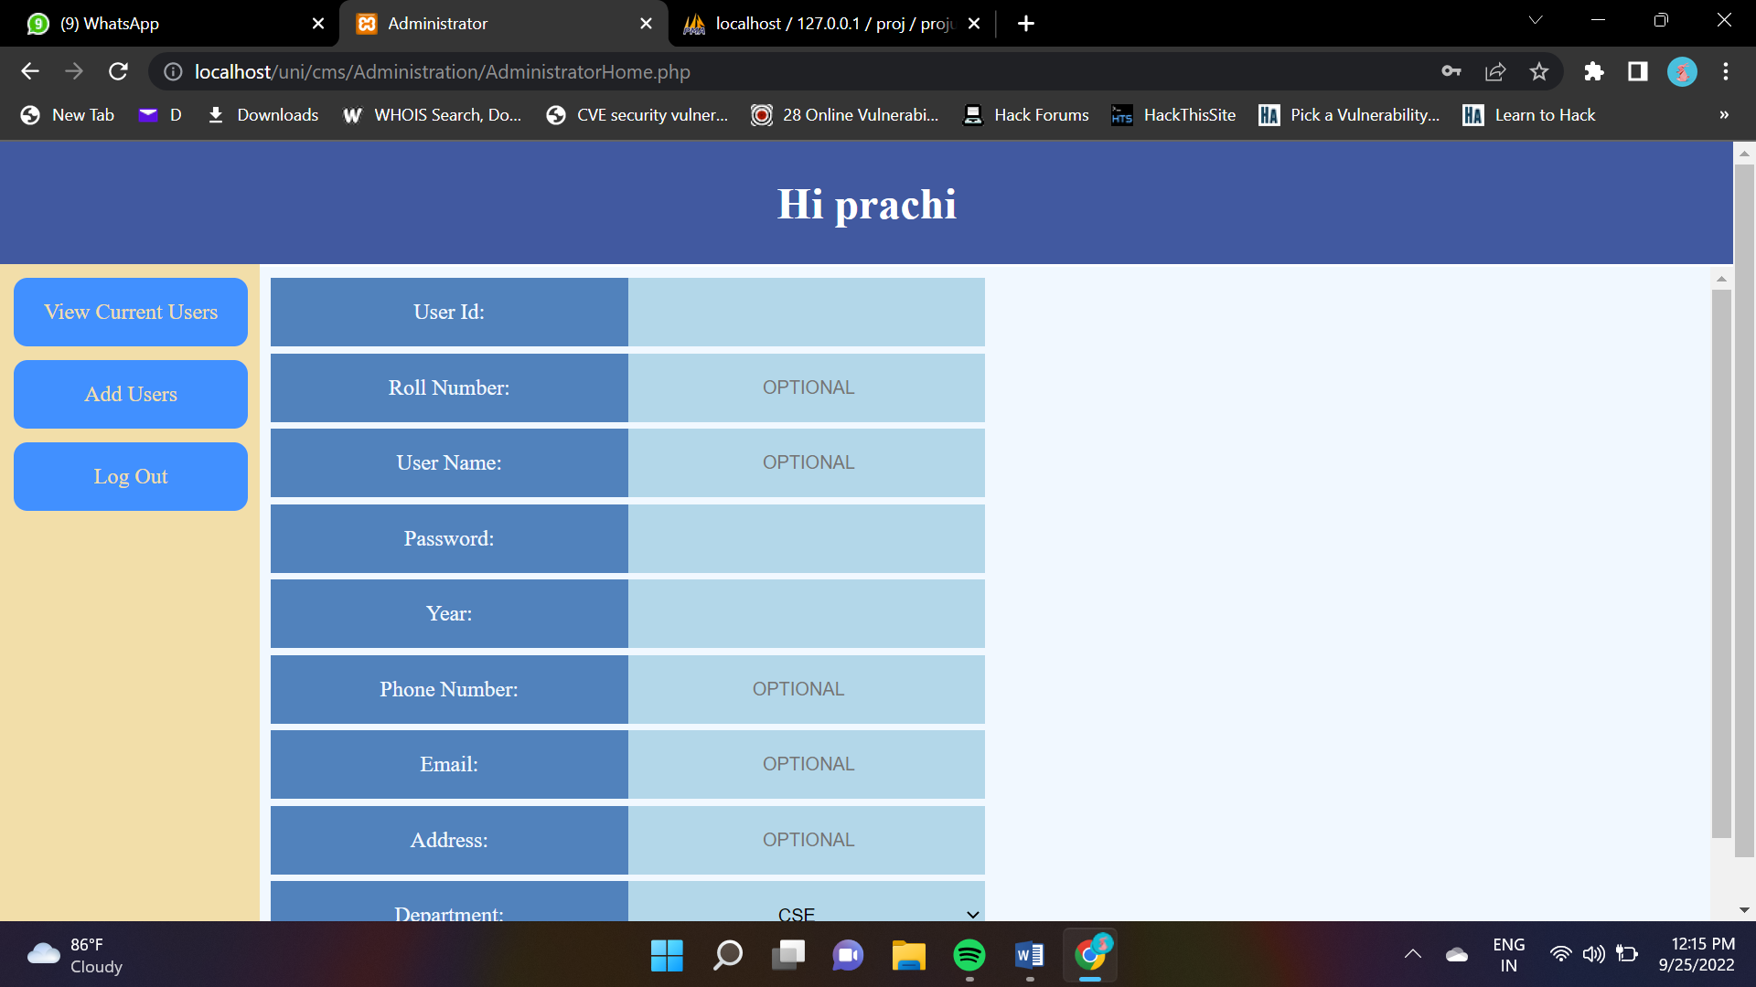

Faculty side:

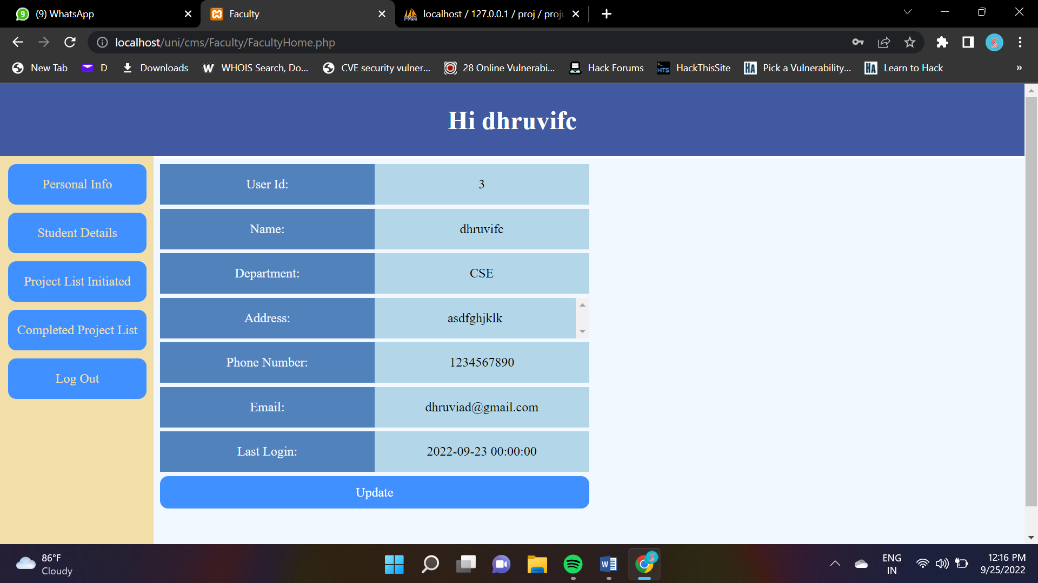

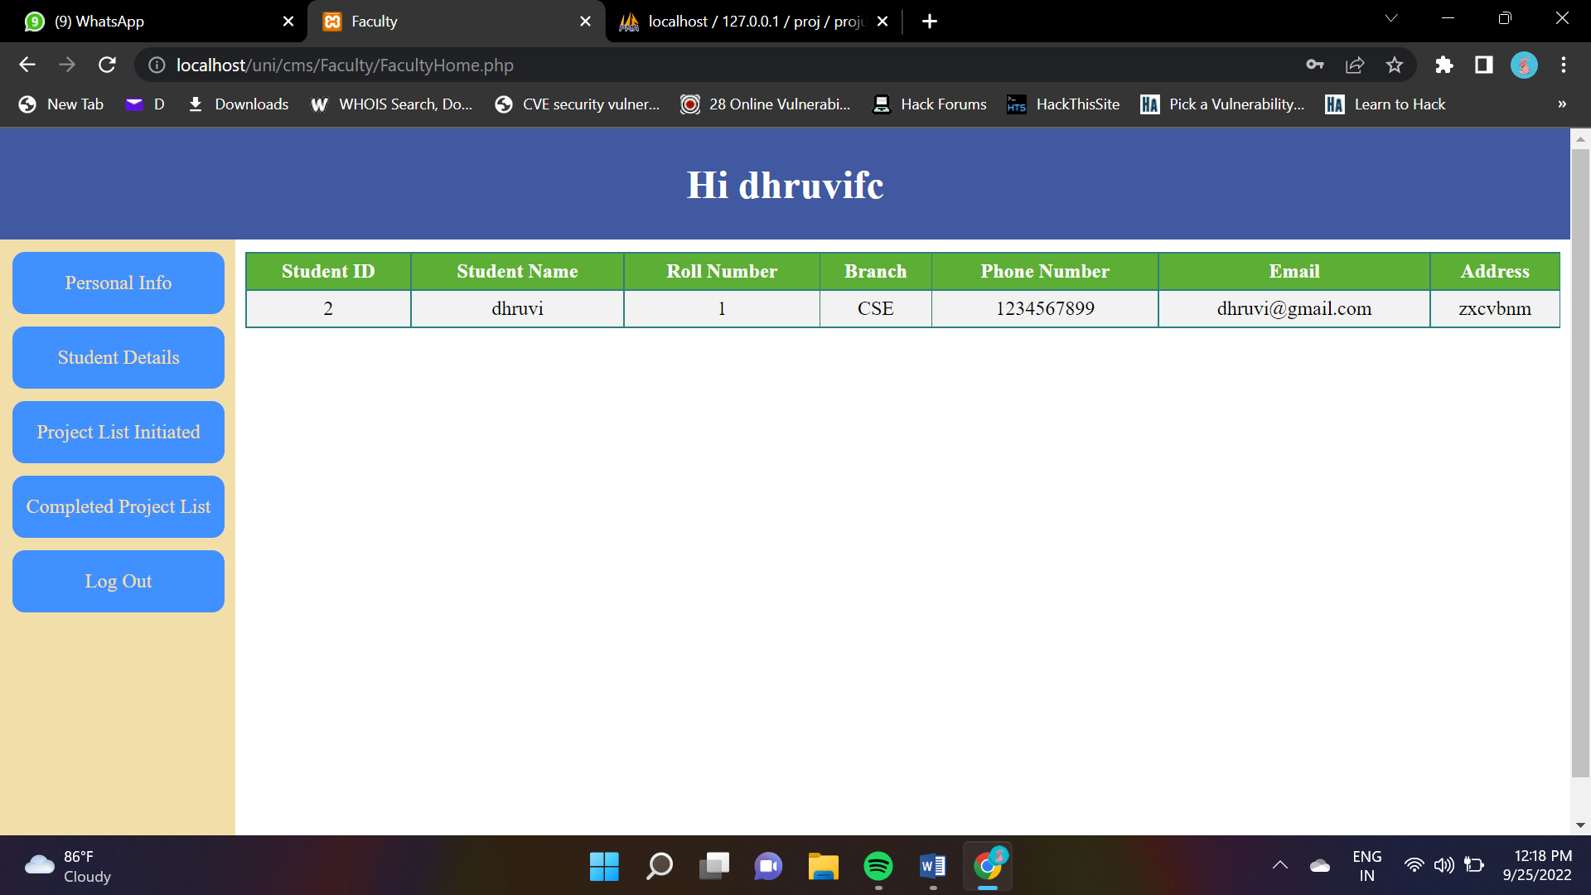

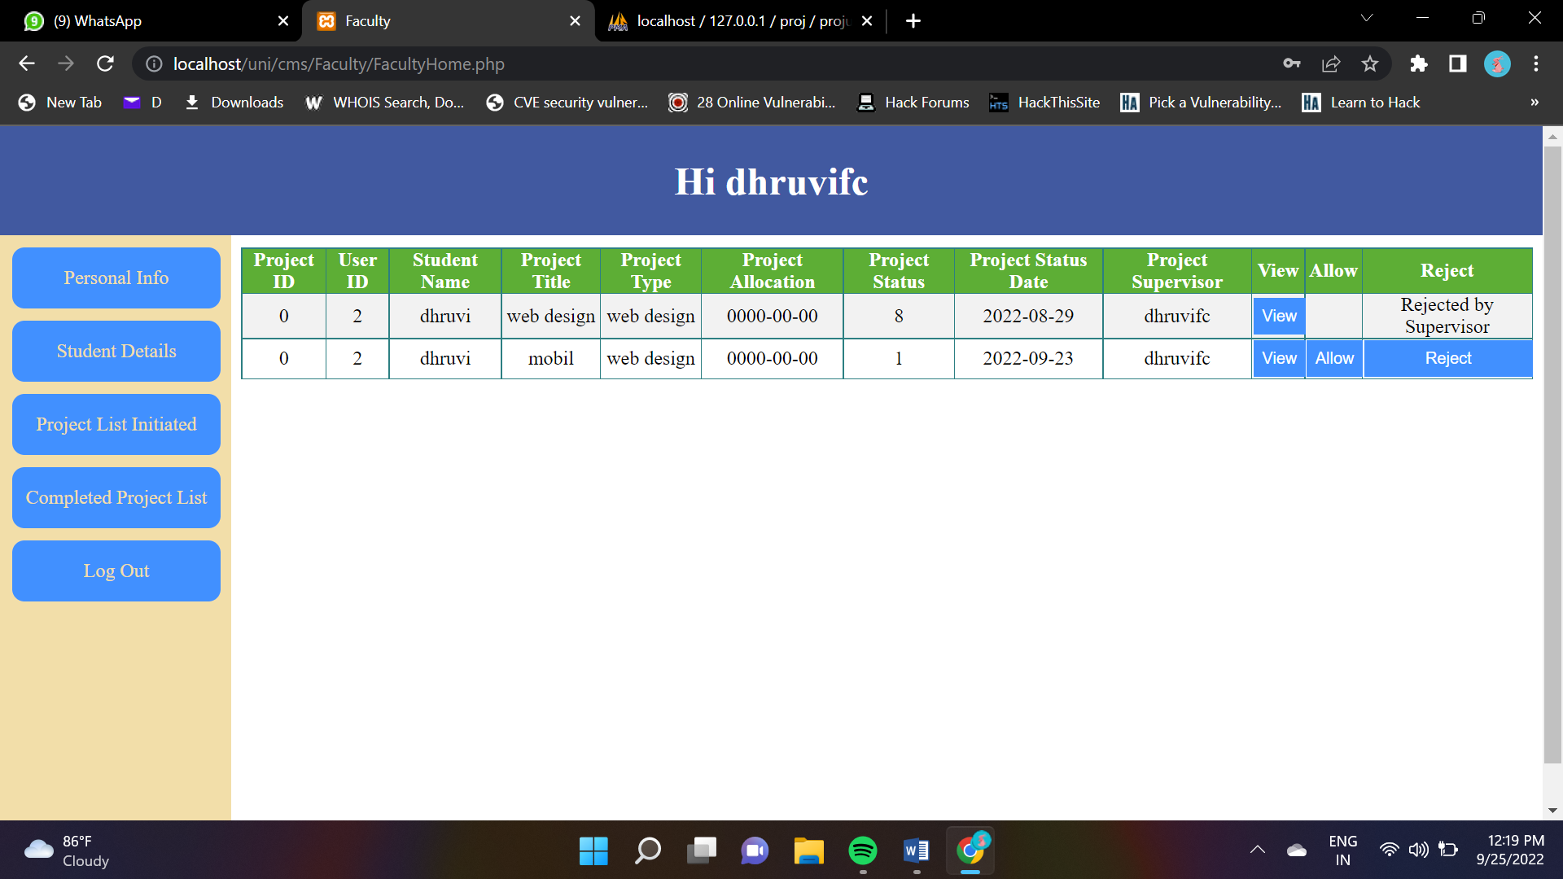

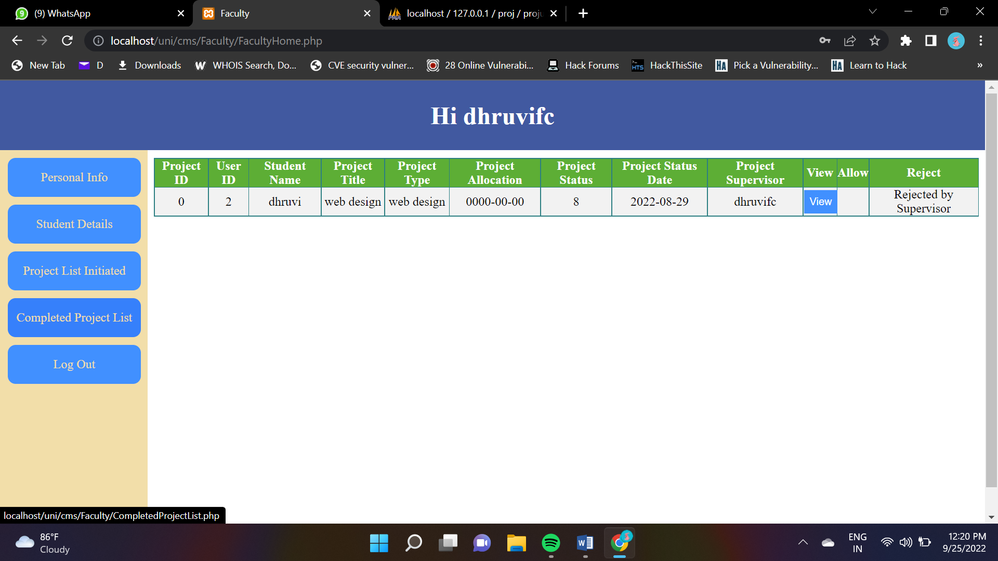

Student side:

